**Working with a Linux VM in the cloud**

**By**

**Israel Nolazco**

The following exercise we’ll properly show how to operate a Linux Virtual Machine (VM) that was created in the cloud and remotely connected to it by an SSH client. This exercise will be conducted on a MAC; therefore, there will be no need to use applications like PUTTY/MOBAXTERM.

1. First let’s log on to our AWS Management console. Then we are going over EC2. There we create a new instance. The new instance will have a guided selection tool to create a Linux VM. (Note: This exercise will primarily use free tier options by AWS. However, the premise and overall actions should still be the same.). The below image shows an instance of a Linux VM running and located in a the US-East-2C location (Ohio region).

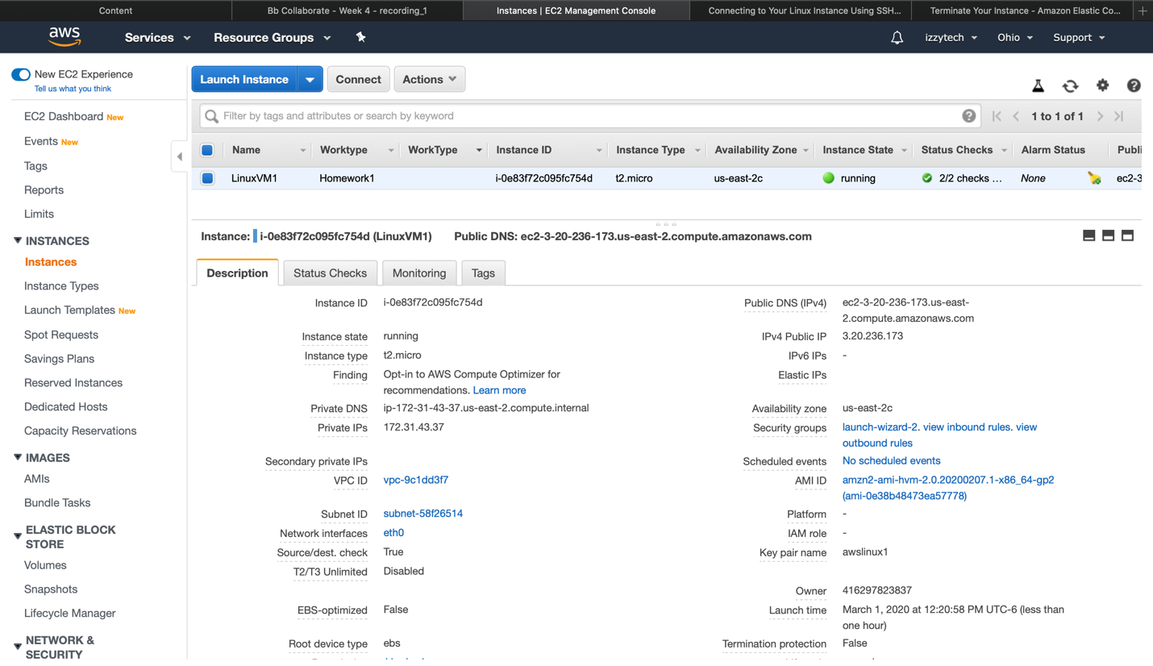

1. During the creation of the instance there will be a .PEM file created along. It is crucial to download said file and store it in a location that cannot be misplace. Additionally, it is important to notate both private and public IP addresses as those will be needed in order to connect to our Linux VM.
2. Mac users will need to use the command chmod 600 this is to set the permission of the file or directories. In essence, we are setting predefined permission for the .PEM file, so there forward can be a middle point for the SSH client communication happening between AWS and our computer. To learn more about chmod commands visit here: <https://www.computerhope.com/unix/uchmod.htm>
3. Now, after the permission have been set to our .PEM file, we are going to connect to our Linux VM using the following command template obtain from AWS docs.

ssh -i “.pem” ec2-user@PUBLIC IP.

PLEASE SEE IMAGE BELOW:

1. This step is more of a first-time user preference. As seen in the image provided by step 4. There was a security update available; which for future proof purpose the update was implemented as seen below.

1. Now, we are going to exit our connection to the Linux VM. Create a sample file in our computer. That file will then be copied to our Linux VM by using the scp command. Additionally, the .PEM file will also be transfer to our Linux VM. Afterwards, we are going to back into our Linux VM and see if our files were successfully transferred.

1. In order to observe how far our commands can take us. We are going to create a second Linux VM machine. The overall purpose of this is to transfer the files from our first machine to our second machine.

1. As a precaution we are going to connect back to our first Linux VM and change the permission of the files we have stored there by using again the command chmod 600. Then we are going to exit our 1st Linux VM and connect back to our 2nd Linux VM. The image below will also show our 2nd Linux VM is also empty.

1. Having verified the emptiness of our 2nd Linux VM and having verified our files/folders in our 1st Linux VM have a chmod 600 permission. We are going to transfers files from the 1st Linux VM to our 2nd Linux VM. By again using the scp command. Lastly, we are going to confirmed the existence of the files in our 2nd Linux VM.

1. Finally, we are going to stop all of our instances because we are still using a free tier version of AWS.

